Experiment 1.2
Obstacle Avoidance Robot using Arduino (Hardware)
Aim
To design, build and program an autonomous obstacle avoidance robot using an Arduino Uno, an HC-SR04 ultrasonic sensor mounted on an SG90 servo motor and an L298N motor driver, where the robot detects obstacles in its path and automatically changes direction to avoid them.
Theory
An obstacle avoidance robot is a mobile robot that moves on its own and changes its path whenever it detects an object in front of it, without any human control. It is one of the basic building blocks of autonomous vehicles, warehouse robots and robotic vacuum cleaners.
In this experiment, the Arduino Uno acts as the brain of the robot. It continuously measures the distance to objects in front of the robot using an ultrasonic sensor.
- HC-SR04 Ultrasonic Sensor: sends a 40 kHz sound pulse from its Trig side and listens for the echo on its Echo side. The time taken by the echo to return is used to calculate distance.
Distance calculation: Sound travels at about 343 m/s (0.034 cm/µs). Because the pulse travels to the object and back, the distance is:
Distance (cm) = Echo Time (µs) × 0.034 ÷ 2
The L298N is a dual H-bridge motor driver. It takes low-current control signals from the Arduino (IN1–IN4) and switches the high current from the 12 V battery to the two DC motors. The direction of each motor is set by the IN pins, and the speed is set by a PWM signal on ENA and ENB.
The SG90 servo motor rotates the ultrasonic sensor to 20° (right) and 160° (left) so the robot can “look around” before turning. The robot moves forward while the path is clear. When an obstacle is detected within 25 cm, it stops, reverses a short distance, scans both sides, and turns towards the side with more free space. If both sides are blocked, it turns around.
Software Requirements
Software | Purpose
Arduino IDE (1.8.x / 2.x) | Writing, compiling and uploading code
Servo library (built into Arduino IDE) | Controlling the SG90 servo motor
CH340 USB Driver (for clone boards) | Allows the computer to detect the Arduino
Serial Monitor (in Arduino IDE) | Viewing sensor readings and robot status
Hardware Requirements
Component | Quantity
Arduino Uno + USB cable | 1
HC-SR04 Ultrasonic Sensor | 1
SG90 Micro Servo Motor | 1
L298N Motor Driver Module | 1
2WD Robot Chassis (2 BO gear motors, 2 wheels, 1 caster wheel) | 1
12 V Battery (3S Li-ion / Li-Po pack recommended) | 1
Ultrasonic Sensor Mounting Bracket | 1
Mini Breadboard (for sharing GND connections) | 1
Jumper Wires (M-M, M-F, F-F) | As required
Screws, nuts, spacers, double-sided tape, zip ties | As required
Screwdriver, wire stripper, soldering iron (optional) | 1 set
Circuit Diagram
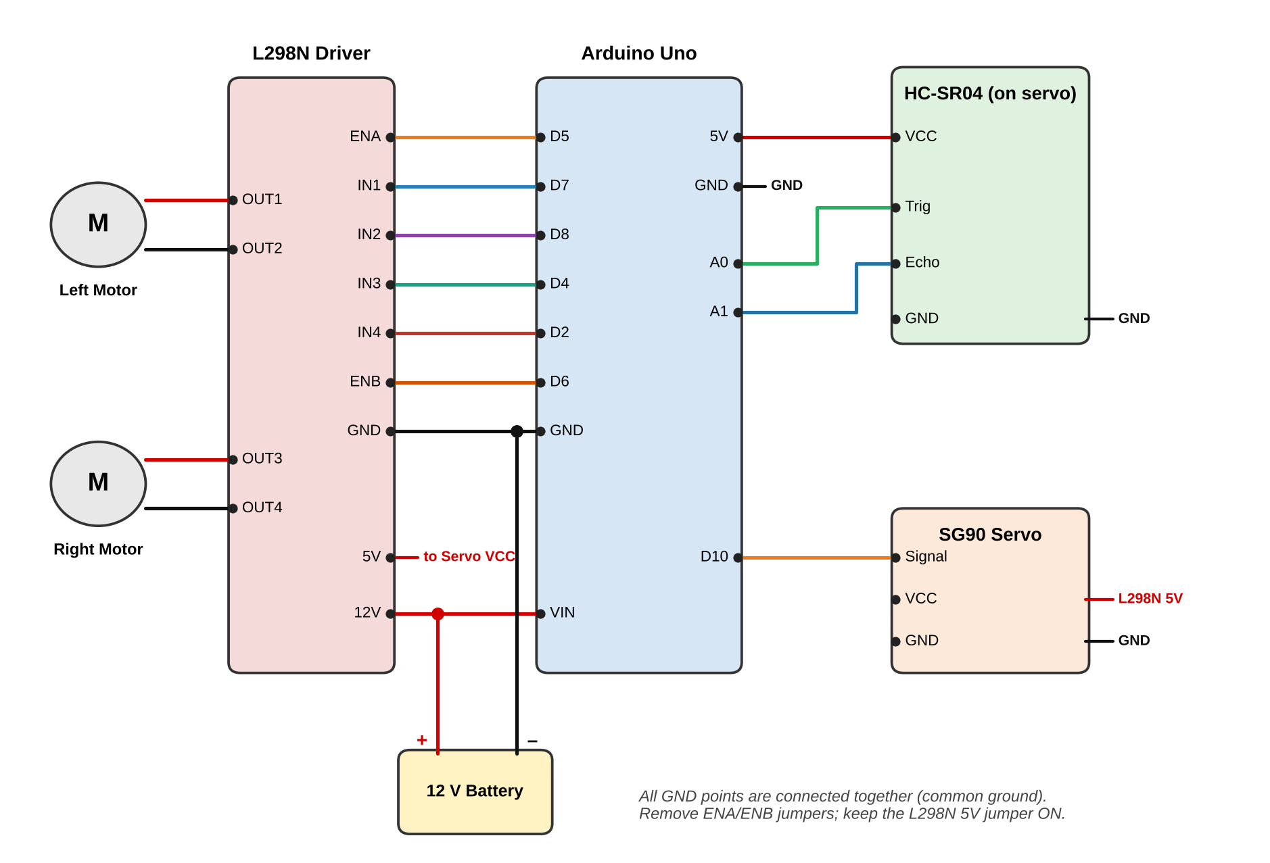
Figure 1: Circuit connections of the obstacle avoidance robot
Installation Steps (Windows & macOS)
The Arduino IDE must be installed on the computer to write and upload the program.
Windows
- Open a web browser and visit arduino.cc/en/software.
- Download the Arduino IDE installer for Windows.
- Run the installer and allow it to install the USB drivers.
- If the board is a clone with a CH340 chip, install the CH340 driver.
- Connect the Arduino Uno with the USB cable and open the Arduino IDE.
- Select Tools → Board → Arduino Uno and Tools → Port → COMx.
macOS
- Visit arduino.cc/en/software and download the macOS version.
- Open the .dmg file and drag Arduino IDE into the Applications folder.
- Install the CH340 driver if a clone board is used.
- Connect the Arduino and open the Arduino IDE.
- Select Tools → Board → Arduino Uno and Tools → Port → /dev/cu.usbserial-xxxx or /dev/cu.usbmodem-xxxx.
Project Workflow
The obstacle avoidance robot follows a simple sense–decide–act workflow.
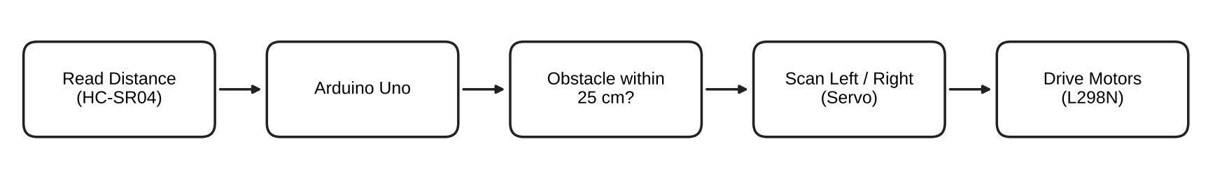
Working Logic
- The HC-SR04 sends an ultrasonic pulse and receives its echo from the object in front.
- The Arduino triggers the sensor on pin A0 and reads the echo time on pin A1.
- The echo time is converted into distance in centimetres (average of 3 readings).
- If the distance is more than 25 cm, the robot moves forward.
- If the distance is 25 cm or less, the robot stops, reverses for 400 ms and stops again.
- The servo turns the ultrasonic sensor right (20°) and left (160°) and measures the distance on each side.
- The robot turns towards the side with more space. If both sides are blocked, it turns around.
- All readings and decisions are displayed on the Serial Monitor.
Flowchart
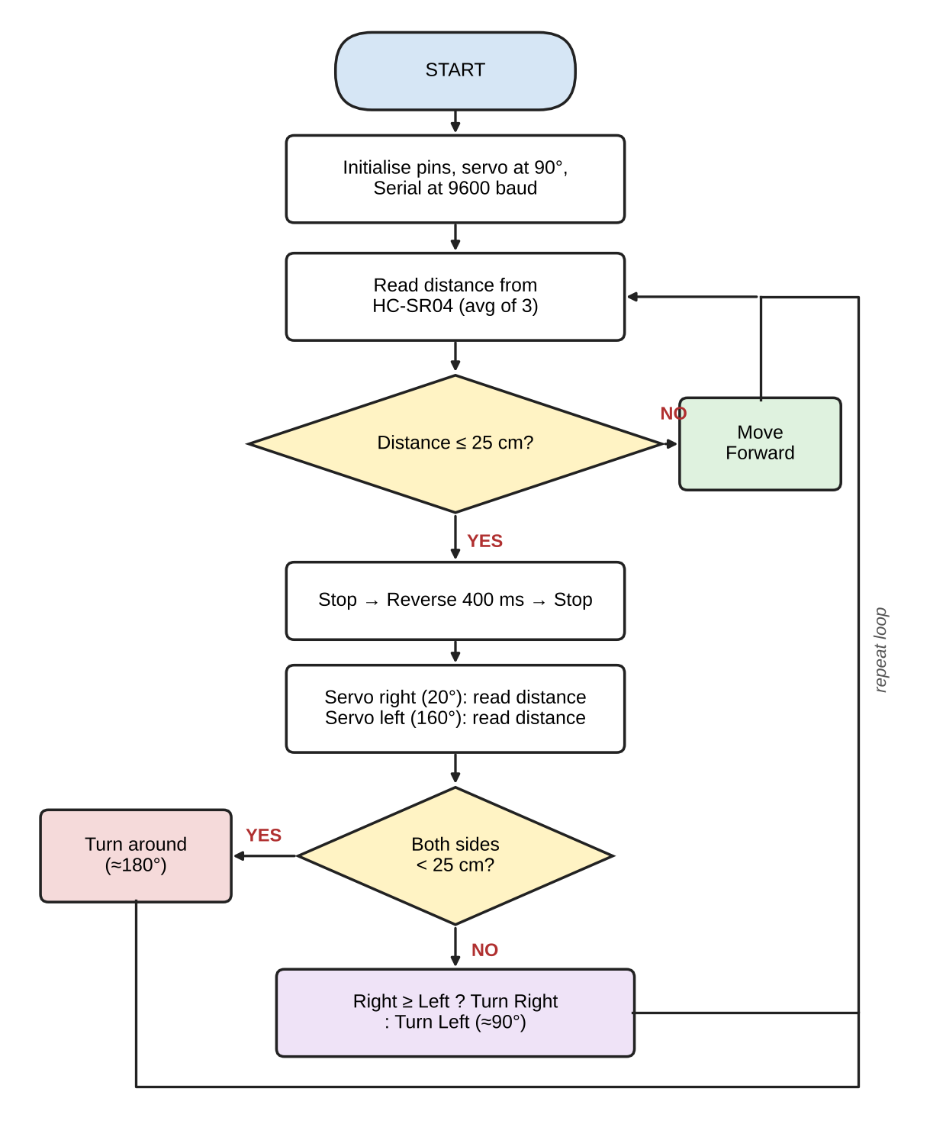
Figure 2: Flowchart of the robot's control program
Procedure
Step 1: Assemble the Chassis
- Fix the two BO gear motors to the chassis plate using the motor brackets and screws.
- Push the wheels onto the motor shafts.
- Mount the caster wheel at the front or rear of the chassis.
- Attach two wires to each motor's terminals.
Step 2: Mount the Electronics
- Fix the Arduino Uno and the L298N on the chassis using spacers or double-sided tape.
- Mount the 12 V battery securely in the middle of the chassis for balance.
- Fix the SG90 servo at the front centre and centre it at 90° before attaching the bracket.
- Attach the HC-SR04 to the servo bracket so it faces straight ahead.
Step 3: Connect the Circuit
L298N Motor Driver
L298N Pin | Arduino Pin | Function
ENA | D5 | Left motor speed (PWM)
IN1 | D7 | Left motor direction
IN2 | D8 | Left motor direction
IN3 | D4 | Right motor direction
IN4 | D2 | Right motor direction
ENB | D6 | Right motor speed (PWM)
GND | GND | Common ground
Note: Remove the ENA and ENB jumpers on the L298N. Keep the 5V jumper ON.
DC Motors
Motor | L298N Terminal
Left Motor | OUT1 and OUT2
Right Motor | OUT3 and OUT4

HC-SR04 Ultrasonic Sensor
Pin | Arduino
VCC | 5V
Trig | A0
Echo | A1
GND | GND

SG90 Servo Motor
Wire | Connection
Orange (Signal) | Arduino D10
Red (VCC) | L298N 5V terminal
Brown (GND) | Arduino GND

12 V Battery
Battery Terminal | Connection
+ (Red) | L298N 12V terminal and Arduino VIN
– (Black) | L298N GND terminal and Arduino GND
Important: All grounds (battery –, L298N, Arduino, HC-SR04 and servo) must be connected together. Keep D0 and D1 free, as they are used for uploading code.
Step 4: Upload the Arduino Code
Disconnect the 12 V battery, connect the Arduino to the computer using the USB cable, paste the program into the Arduino IDE and click Upload.
The program:
- Measures distance using the HC-SR04 (average of 3 readings).
- Moves the robot forward when the path is clear.
- Stops, reverses and scans left and right using the servo when an obstacle is found.
- Turns towards the side with more space.
- Displays readings on the Serial Monitor.
CODE:
/*
Obstacle Avoiding Robot - Arduino Uno
Power: 12 V battery (no switch)

Wiring:
L298N ENA -> D5 IN1 -> D7 IN2 -> D8
ENB -> D6 IN3 -> D4 IN4 -> D2
GND -> Arduino GND, 12V -> Battery +
5V output -> Servo red wire (keep 5V jumper ON)
HC-SR04 VCC -> 5V Trig -> A0 Echo -> A1 GND -> GND
Servo Signal (orange) -> D10, GND (brown) -> GND
Battery + -> Arduino VIN, Battery - -> Arduino GND
*/

#include <Servo.h>

// ---------- Motor driver pins ----------
const int ENA = 5; // Left motor speed (PWM)
const int IN1 = 7;
const int IN2 = 8;
const int ENB = 6; // Right motor speed (PWM)
const int IN3 = 4;
const int IN4 = 2;

// ---------- Sensor & servo pins ----------
const int TRIG = A0;
const int ECHO = A1;
const int SERVO_PIN = 10;

// ---------- Settings (tune these) ----------
const int SPEED = 110; // Forward/backward speed (0-255), low for 12 V
const int TURN_SPEED = 130; // Turning speed
const int STOP_DIST = 25; // Obstacle distance in cm
const int BACK_TIME = 400; // ms to reverse
const int TURN_TIME = 300; // ms to turn ~90 degrees

const int SERVO_CENTER = 90;
const int SERVO_RIGHT = 20;
const int SERVO_LEFT = 160;

Servo head;

// ---------- Distance measurement ----------
long readDistance() {
digitalWrite(TRIG, LOW);
delayMicroseconds(2);
digitalWrite(TRIG, HIGH);
delayMicroseconds(10);
digitalWrite(TRIG, LOW);

long duration = pulseIn(ECHO, HIGH, 30000); // 30 ms timeout
if (duration == 0) return 400; // nothing in range
return duration * 0.034 / 2; // convert to cm
}

// Average of 3 readings to filter noise
long getDistance() {
long total = 0;
for (int i = 0; i < 3; i++) {
total += readDistance();
delay(10);
}
return total / 3;
}

// ---------- Motor control ----------
void setMotors(int a1, int a2, int b1, int b2, int spd) {
digitalWrite(IN1, a1);
digitalWrite(IN2, a2);
digitalWrite(IN3, b1);
digitalWrite(IN4, b2);
analogWrite(ENA, spd);
analogWrite(ENB, spd);
}

void moveForward() { setMotors(HIGH, LOW, HIGH, LOW, SPEED); }
void moveBackward() { setMotors(LOW, HIGH, LOW, HIGH, SPEED); }
void turnLeft() { setMotors(LOW, HIGH, HIGH, LOW, TURN_SPEED); }
void turnRight() { setMotors(HIGH, LOW, LOW, HIGH, TURN_SPEED); }
void stopMotors() { setMotors(LOW, LOW, LOW, LOW, 0); }

// ---------- Look in a direction and measure ----------
long lookAt(int angle) {
head.write(angle);
delay(400); // let servo reach position
long d = getDistance();
head.write(SERVO_CENTER);
delay(300);
return d;
}

// ---------- Setup ----------
void setup() {
pinMode(ENA, OUTPUT);
pinMode(IN1, OUTPUT);
pinMode(IN2, OUTPUT);
pinMode(ENB, OUTPUT);
pinMode(IN3, OUTPUT);
pinMode(IN4, OUTPUT);
pinMode(TRIG, OUTPUT);
pinMode(ECHO, INPUT);

stopMotors();
head.attach(SERVO_PIN);
head.write(SERVO_CENTER);

Serial.begin(9600);
Serial.println("Obstacle Avoiding Robot Ready");
delay(2000); // time to place robot on the floor
}

// ---------- Main loop ----------
void loop() {
long distance = getDistance();
Serial.print("Distance: ");
Serial.print(distance);
Serial.println(" cm");

if (distance > STOP_DIST) {
moveForward();
} else {
// Obstacle detected
stopMotors();
delay(200);

moveBackward();
delay(BACK_TIME);
stopMotors();
delay(200);

long rightDist = lookAt(SERVO_RIGHT);
long leftDist = lookAt(SERVO_LEFT);

Serial.print("Right: ");
Serial.print(rightDist);
Serial.print(" cm | Left: ");
Serial.print(leftDist);
Serial.println(" cm");

if (rightDist < STOP_DIST && leftDist < STOP_DIST) {
// Both sides blocked: turn around
turnRight();
delay(TURN_TIME * 2);
} else if (rightDist >= leftDist) {
turnRight();
delay(TURN_TIME);
} else {
turnLeft();
delay(TURN_TIME);
}
stopMotors();
delay(200);
}
delay(50);
}

Step 5: Test and Calibrate
- Open the Serial Monitor (Tools → Serial Monitor) at 9600 baud.
- Move your hand in front of the HC-SR04 and check that the distance value changes.
- Place an object at known distances (e.g. 10, 20, 50 cm) and compare with the Serial Monitor reading.
- Check that the servo centres at 90° when the program starts.
- Lift the wheels and connect the battery. If a wheel spins backwards, swap that motor's two wires.
Step 6: Run the Robot
- Disconnect the USB cable.
- Place the robot on the floor and connect the 12 V battery.
- Place obstacles (boxes, books, walls) in its path and observe the behaviour.
- Tune SPEED, STOP_DIST and TURN_TIME in the code if needed.
Expected Output
The robot behaves according to the distance of the obstacle in front of it.
Condition | Distance | Robot Action
Path clear | > 25 cm | Moves forward
Obstacle ahead | ≤ 25 cm | Stops, reverses, scans
Right side more open | Right ≥ Left | Turns right
Left side more open | Left > Right | Turns left
Both sides blocked | Both < 25 cm | Turns around
Serial Monitor Output
Sample output seen on the Serial Monitor while the robot is running:
Obstacle Avoiding Robot Ready
Distance: 112 cm
Distance: 86 cm
Distance: 41 cm
Distance: 22 cm
Right: 18 cm | Left: 95 cm
Distance: 140 cm
Distance: 64 cm
Distance: 19 cm
Right: 120 cm | Left: 35 cm

Observations
S. No. | Actual Distance (cm) | Measured Distance (cm) | Error (cm) | Robot Action
1 | 100
2 | 50
3 | 30
4 | 25
5 | 20
6 | 10
(Fill in the measured values and robot action during the experiment.)
During the experiment:
- The robot moves forward smoothly when no obstacle is present.
- The servo sweeps the ultrasonic sensor left and right whenever an obstacle is detected.
- The distance on the Serial Monitor decreases as the robot approaches an obstacle.
- The robot always turns towards the side with more free space.
Result
The obstacle avoidance robot was successfully built and programmed using an Arduino Uno. The robot measured the distance to obstacles using the HC-SR04 ultrasonic sensor, scanned its surroundings using the SG90 servo, and controlled its motors through the L298N driver to avoid obstacles autonomously.
Precautions
- Disconnect the 12 V battery before uploading code or changing any wiring.
- Check the battery polarity carefully before connecting it to VIN and the L298N.
- Connect all grounds together (common ground).
- Keep pins D0 and D1 free.
- Remove the ENA/ENB jumpers so the Arduino can control motor speed.
- Do not run the motors at full speed on 12 V for long periods; keep SPEED low.
- Lift the wheels off the ground during the first test.
- Unplug the battery when the robot is not in use.
Troubleshooting
Problem | Possible Solution
“Programmer is not responding” during upload | Select the correct board and port, install the CH340 driver, remove wires from D0/D1, try another USB cable
Robot does not move | Check battery charge, 12V and GND wiring, and the ENA/ENB connections
One wheel spins backwards | Swap that motor's wires on the L298N output
Distance always 0 or 400 | Check the Trig (A0) and Echo (A1) wiring and the 5V supply
Robot reacts too late | Increase STOP_DIST or reduce SPEED in the code
Servo jitters or Arduino resets | Make sure the servo is powered from the L298N 5V output
Applications
- Autonomous vehicles and driver assistance systems.
- Robotic vacuum cleaners.
- Warehouse and industrial material-handling robots.
- Search and rescue robots in unknown areas.
- Smart wheelchairs and assistive devices.
- Agricultural and surveillance robots.
Learning Outcome
After completing this experiment, students will be able to:
- Interface an ultrasonic sensor with an Arduino.
- Calculate distance using the time-of-flight principle.
- Control DC motor direction and speed using an L298N H-bridge driver.
- Control a servo motor using the Servo library.
- Implement decision-making logic for autonomous navigation.
- Build, test and troubleshoot a complete robotic system.
Viva Questions
Q1. What is the working principle of the HC-SR04?
Ans: It sends an ultrasonic pulse and measures the time taken by the echo to return. Distance = time × 0.034 ÷ 2.
Q2. Why do we divide by 2 in the distance formula?
Ans: Because the sound travels to the object and back, covering the distance twice.
Q3. Why is an L298N motor driver needed?
Ans: Arduino pins can supply only about 20–40 mA, while motors need much more current. The L298N switches the battery current to the motors.
Q4. What is PWM and where is it used here?
Ans: Pulse Width Modulation varies the average voltage. It is used on ENA and ENB to control motor speed.
Q5. Why is a common ground necessary?
Ans: All signals are measured with respect to ground; without a common ground, the control signals are not understood correctly.
Q6. Why is the ultrasonic sensor mounted on a servo?
Ans: So the robot can measure the free space on its left and right before deciding which way to turn.
Q7. What is the range of the HC-SR04?
Ans: About 2 cm to 400 cm, with an accuracy of about 3 mm.

